Item | Unismart contactors’ position changed
Reason of Change | Unismart contactors’ position changed

- Appearance:
Before | After
PCB Code: 4J1120  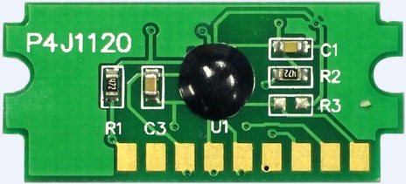  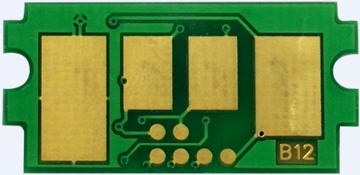 | 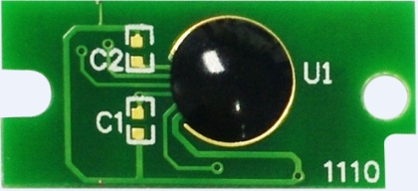  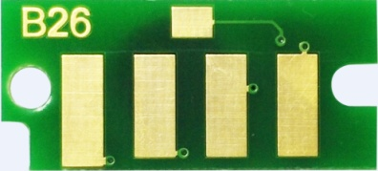  PCB Code: 4J1170  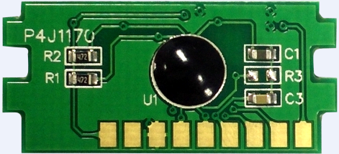    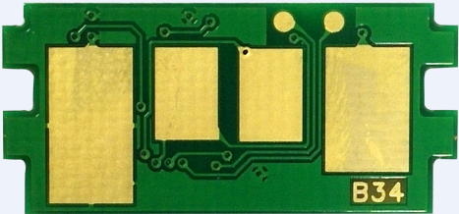
Changes:
- Face with wafer: laser marking is changed from 1120 to 1170.
- Face with contactors: Unismart contactors are moved to the top of the chip and the Unismart character is changed from B12 to B34 (laser marking position is same as before, see the red square).

- There is no change occurred to the Product Size.
- Coding:
Before | K4J1120B-XXXX, e.g. K4J1120B-TK3152/U
After | K4J1170-XXXX, e.g. K4J1170-TK3152/U

- There is no change occurred to the Printer Shown Information and Print Supplies Status Page.
- Test Report: tests items were same as before. All tests were passed.
- There is no change occurred to the Installation Method.
- There is no change occurred to Laser Marking Position.
- There is no change occurred to Chip Function.
- Available Date:
Available date of the changed product sample:
August 25th
Available date of the changed product:
September 13th

- Model List:
Apex Product Code | OEM Code | Color | Yields | Region | For Use in Printer
ALE-3T26 | LPB3T26 | BK | 5.9k | JPN | Epson LP-S3550/S3550PS/S3550Z/S4250/S4250PS
ALE-3T28 | LPB3T28 | BK | 6.1K | JPN | Epson LP-S3250/S3250PS/S3250Z
ALE-3T29 | LPB3T29 | BK | 14.1K | JPN
ALE-3T27 | LBP3T27 | BK | 15.2K | JPN | Epson LP-S3550/S3550PS/S3550Z/S4250/S4250PS
ALE-0762 | C13S050762 | BK | 21.7K | EUR | Epson WorkForce AL M8100DN
ALK-TK1003 | TK-1003 | BK | 1.2K | CHN | Kyocera ECOSYS FS-1040/FS-1020MFP/FS-1120MFP  Kyocera FS-1040/ECOSYS M1520H
ALK-TK1110 | TK-1110 | BK | 2.5K | EUR
ALK-TK1112 | TK-1112 | BK | 2.5K | USA
ALK-TK1113 | TK-1113 | BK | 2.5K | CHN
ALK-TK1114 | TK-1114 | BK | 2.5K | ASIA
ALK-TK1114K | TK-1114K | BK | 2.5K | KOR
ALK-TK1115 | TK-1115 | BK | 1.6K | EUR | Kyocera ECOSYS FS-1041/FS-1220MFP/FS-1320MFP
ALK-TK1119 | TK-1119 | BK | 1.6K | ASIA
ALK-TK1120 | TK-1120 | BK | 3K | EUR | Kyocera ECOSYS FS-1060DN/FS-1025MFP/FS-1125MFP/FS-1060
ALK-TK1122 | TK-1122 | BK | 3K | USA
ALK-TK1123 | TK-1123 | BK | 3K | CHN
ALK-TK1124 | TK-1124 | BK | 3K | ASIA
ALK-TK1124K | TK-1124K | BK | 3K | KOR
ALK-TK1125 | TK-1125 | BK | 2.1K | EUR | Kyocera ECOSYS FS-1061DN/FS-1325MFP
ALK-TK1129 | TK-1129 | BK | 2.1K | ASIA
ALK-TK3100 | TK-3100 | BK | 12.5K | EUR | Kyocera FS-2100D/2100DN/Ecosys M3040dn/M3540dn
ALK-TK3101 | TK-3101 | BK | 12.5K | JPN | Kyocera LS-2100DN/Ecosys M3540idn
ALK-TK3102 | TK-3102 | BK | 12.5K | USA | Kyocera FS-2100DN/Ecosys M3040dn/M3540dn/ Ecosys M3540idn
ALK-TK3103 | TK-3103 | BK | 12.5K | CHN | Kyocera FS-2100DN
ALK-TK3104 | TK-3104 | BK | 12.5K | ASIA | Kyocera FS-2100DN
ALK-TK3104K | TK-3104K | BK | 12.5K | KOR
ALK-TK3100 | TK-3100 | BK | 12.5K | EUR | Kyocera FS-4100DN
ALK-TK3110 | TK-3110 | BK | 15.5K | EUR
ALK-TK3112 | TK-3112 | BK | 15.5K | USA
ALK-TK3113 | TK-3113 | BK | 15.5K | CHN
ALK-TK3114 | TK-3114 | BK | 15.5K | ASIA
ALK-TK3114K | TK-3114K | BK | 15.5K | KOR
ALK-TK3100 | TK-3100 | BK | 12.5K | EUR | Kyocera FS-4200DN  Kyocera FS-4300DN
ALK-TK3110 | TK-3110 | BK | 15.5K | EUR
ALK-TK3130 | TK-3130 | BK | 25K | EUR
ALK-TK3131 | TK-3131 | BK | 25K | JPN
ALK-TK3120 | TK-3120 | BK | 21K | EUR | Kyocera FS-4200DN
ALK-TK3122 | TK-3122 | BK | 21K | USA
ALK-TK3130 | TK-3130 | BK | 25K | EUR | Kyocera FS-4300DN  ECOSYS M3550idn/ECOSYS M3560idn
ALK-TK3132 | TK-3132 | BK | 25K | USA
ALK-TK3133 | TK-3133 | BK | 25K | CHN
ALK-TK3134 | TK-3134 | BK | 25K | ASIA
ALK-TK3134K | TK-3134K | BK | 25K | KOR
ALK-TK3150 | TK-3150 | BK | 14.5K | EUR | Kyocera ECOSYS M3040idn/ECOSYS M3540idn
ALK-TK3152 | TK-3152 | BK | 14.5K | USA
ALK-TK4105 | TK-4105 | BK | 15K | EUR | Kyocera TASKalfa 1800/ 2200  Kyocera TASKalfa 1801/2201
ALK-TK4107 | TK-4107 | BK | 15K | NA
ALK-TK4108 | TK-4108 | BK | 7.2K | CHN
ALK-TK4118 | TK-4118 | BK | 18K | CHN
ALK-TK4109 | TK-4109 | BK | 15K | ASIA
ALK-TK4109K | TK4109K | BK | 15K | KOR
ALK-TK7300 | TK-7300 | BK | 15K | EUR | Kyocera ECOSYS P4040dn
ALK-TK7301 | TK-7301 | BK | 25K | JPN
ALK-TK7302 | TK-7302 | BK | 15K | USA
ALK-TK7303 | TK-7303 | BK | 15K | CHN
ALK-TK7304 | TK-7304 | BK | 15K | ASIA
ALK-TK7304K | TK-7304K | BK | 15K | KOR
ALK-TK4128BK | TK-4128BK | BK | 7.2K | CHN | Kyocera TASKalfa 2010/2011
ALK-TK4138BK | TK-4138BK | BK | 18K | CHN | Kyocera TASKalfa 2210/2211
ALK-TK5140K | TK-5140K | BK | 7K | EUR | Kyocera ECOSYS M6530cdn  Kyocera ECOSYS M6030cdn/ECOSYS P6130cdn
ALK-TK5140C | TK-5140C | C | 5K
ALK-TK5140M | TK-5140M | M | 5K
ALK-TK5140Y | TK-5140Y | Y | 5K
ALK-TK5141K | TK-5141K | BK | 7K | JPN
ALK-TK5141C | TK-5141C | C | 5K
ALK-TK5141C | TK-5141M | M | 5K
ALK-TK5141Y | TK-5141Y | Y | 5K
ALK-TK5142K | TK-5142K | BK | 7K | USA
ALK-TK5142C | TK-5142C | C | 5K
ALK-TK5143C | TK-5142M | M | 5K
ALK-TK5142Y | TK-5142Y | Y | 5K
ALK-TK5143K | TK-5143K | BK | 7K | CHN
ALK-TK5143C | TK-5143C | C | 5K
ALK-TK5143M | TK-5143M | M | 5K
ALK-TK5143Y | TK-5143Y | Y | 5K
ALK-TK5144K | TK-5144K | BK | 7K | ASIA
ALK-TK5144C | TK-5144C | C | 5K
ALK-TK5144C | TK-5144M | M | 5K
ALK-TK5144C | TK-5144Y | Y | 5K
ALK-TK5144KK | TK-5144KK | BK | 7K | KOR
ALK-TK5144KC | TK-5144KC | C | 5K
ALK-TK5144KC | TK-5144KM | M | 5K
ALK-TK5144KY | TK-5144KY | Y | 5K
ALK-TK5150K | TK-5150K | BK | 12K | EUR | Kyocera ECOSYS M6035cidn Kyocera ECOSYS M6535cidn/ECOSYS P6035cdn
ALK-TK5150C | TK-5150C | C | 10K
ALK-TK5150M | TK-5150M | M | 10K
ALK-TK5150Y | TK-5150Y | Y | 10K
ALK-TK5151K | TK-5151K | BK | 12K | JPN
ALK-TK5151C | TK-5151C | C | 10K
ALK-TK5151C | TK-5151M | M | 10K
ALK-TK5151Y | TK-5151Y | Y | 10K
ALK-TK5152K | TK-5152K | BK | 12K | USA
ALK-TK5152C | TK-5152C | C | 10K
ALK-TK5152M | TK-5152M | M | 10K
ALK-TK5152Y | TK-5152Y | Y | 10K
ALK-TK5154K | TK-5154K | BK | 12K | ASIA
ALK-TK5154C | TK-5154C | C | 10K
ALK-TK5154C | TK-5154M | M | 10K
ALK-TK5154Y | TK-5154Y | Y | 10K
ALK-TK5154KK | TK-5154KK | BK | 12K | KOR
ALK-TK5154KC | TK-5154KC | C | 10K
ALK-TK5154KC | TK-5154KM | M | 10K
ALK-TK5154KY | TK-5154KY | Y | 10K
ALK-TK5160K | TK-5160K | BK | 16K | EUR | Kyocera ECOSYS P7040cdn
ALK-TK5160C | TK-5160C | C | 12K
ALK-TK5160M | TK-5160M | M | 12K
ALK-TK5160Y | TK-5160Y | Y | 12K
ALU-44340 | 4434010010 | BK | 12.5K | EUR | UTAX P4030d/dn/P5030dn
ALU-44345 | 4434510010 | BK | 15.5K |  | UTAX P4530dn/P5030dn
ALU-44360 | 4436010010 | BK | 25K |  | UTAX P-5030DN/6030DN/5035iMFP/6035iMFP
ALU-61401 | 614010010 | BK | 14.5K |  | UTAX P-4030iMFP/4035iMFP
ALU-CK4510 | CK-4510 | BK | 15K |  | UTAX 1855/2256
ALU-PK5011K | PK-5011K | BK | 7K | EUR | Utax P-C3061 DN/3060MFP/3605MFP
ALU-PK5011C | PK-5011C | C | 5K
ALU-PK5011M | PK-5011M | M | 5K
ALU-PK5011Y | PK-5011Y | Y | 5K
ALU-PK5012K | PK-5012K | BK | 12k | EUR | Utax P-C3065MFP*3560DN/3560I MFP/3565I MFP
ALU-PK5012C | PK-5012C | C | 11k
ALU-PK5012M | PK-5012M | M | 11k
ALU-PK5012Y | PK-5012Y | Y | 11k
ALV-B1071 | B1071 | BK | 12.5K | EUR | Olivetti L2140/PG L2150/d-COPIA 4003MF/4004MF
ALV-B1082 | B1082 | BK | 15K |  | Olivetti D-copia 1801Mf/Olivetti d-copia 1801Mf plUSA/Olivetti d-copia 2201Mf/Olivetti d-copia 2201Mf plUSA
ALV-B1072 | B1072 | BK | 15.5K |  | Olivetti L2145/PG L2150
ALV-B1073 | B1073 | BK | 25K |  | Olivetti L2150
ALV-B1142 | B1142 | BK | 14.5K | EUR/AF | Olivetti D-Copia4003MFplUSA/4004MFplUSA

“Apex” herein refers to Apex Microelectronics Co., Ltd. The information contained herein is subject to change without prior notification. Apex shall not be liable for technical or editorial errors or omissions contained herein. Photographed products may not always match the description.

